Working procedure in Jira

1. Checking the register module of ShopZ Bd

Go to the URL of ShopZ BD

Click on register

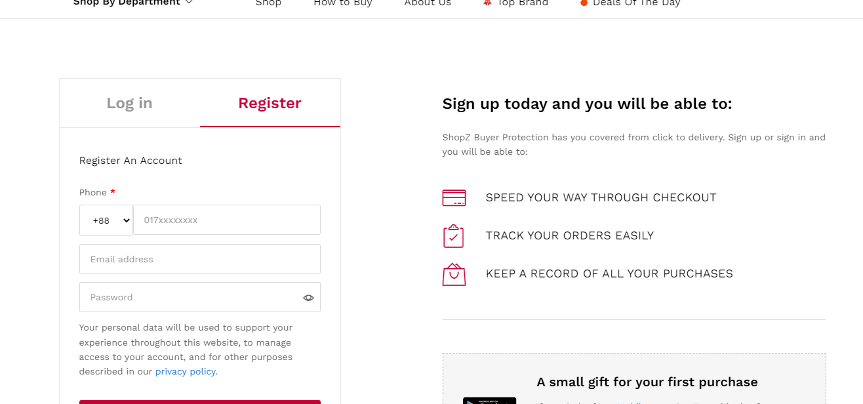

1. Check every unit of the register

Fill up every unit with data

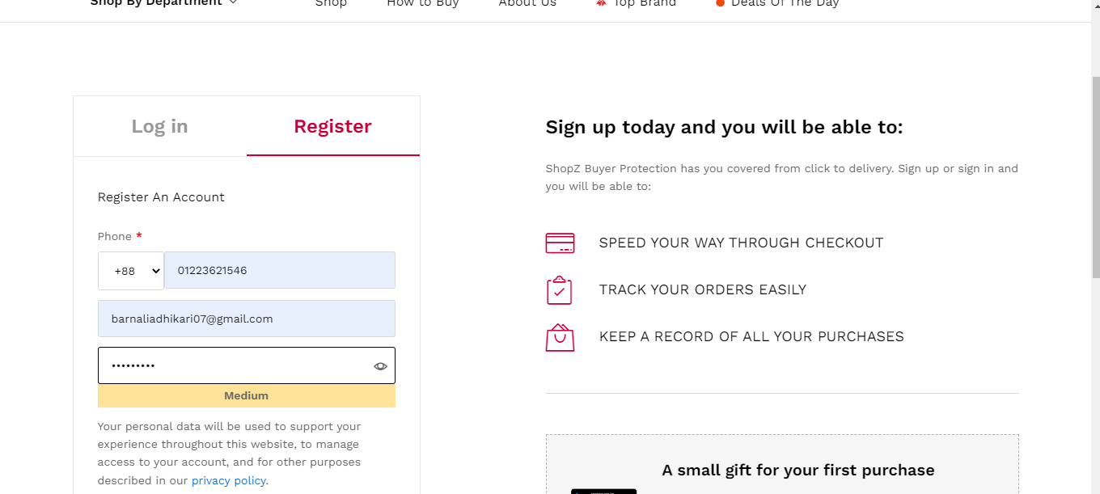

1. Find Out Bug

Find a bug in the phone number Unit

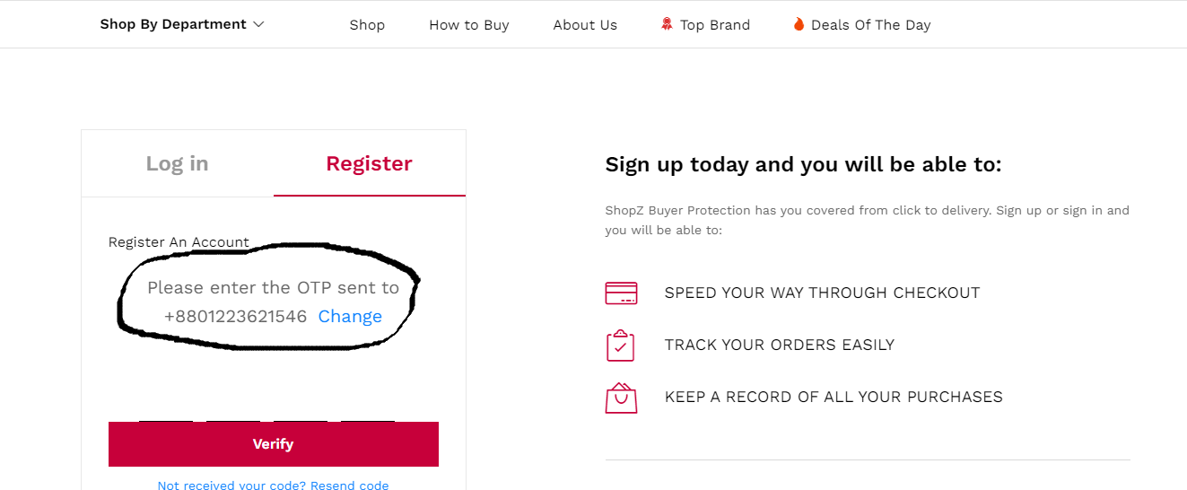

1. Assign the issue to the developer

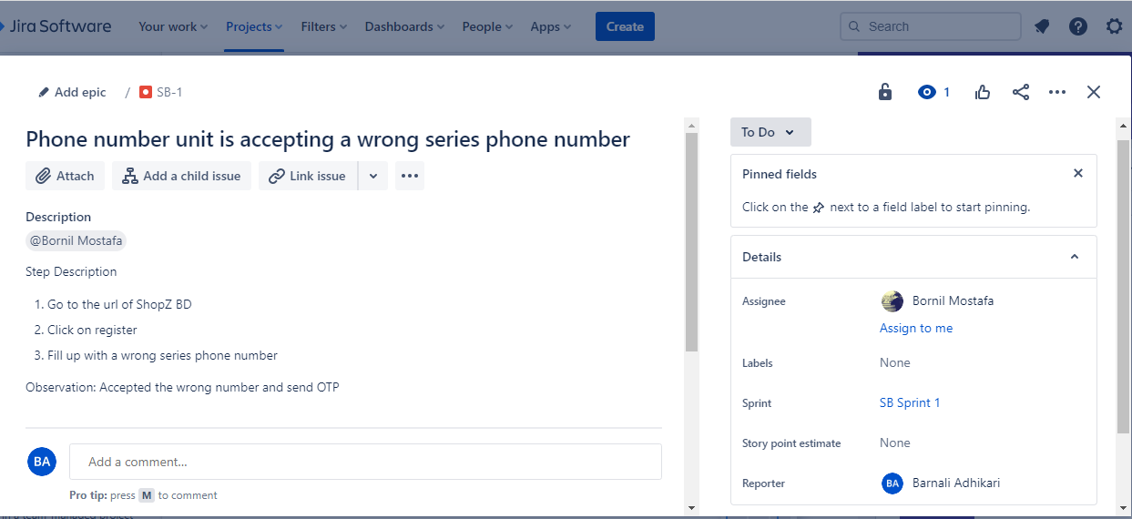

1. Developer Working progress

Developer got an email of this issue and did not start the work yet, the ‘TO DO’ phase indicate this

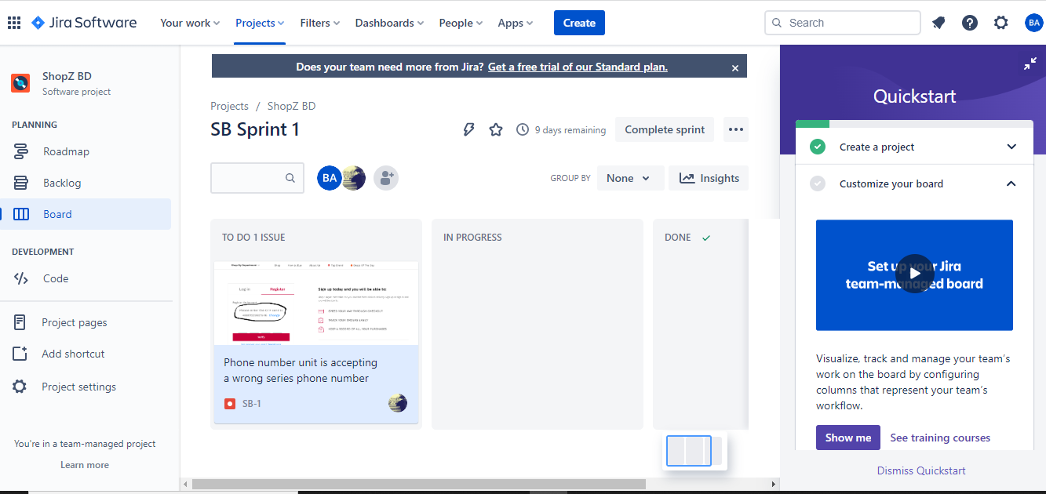

# Developer start working on this issue that’s why the issue is in “In Progress” phase

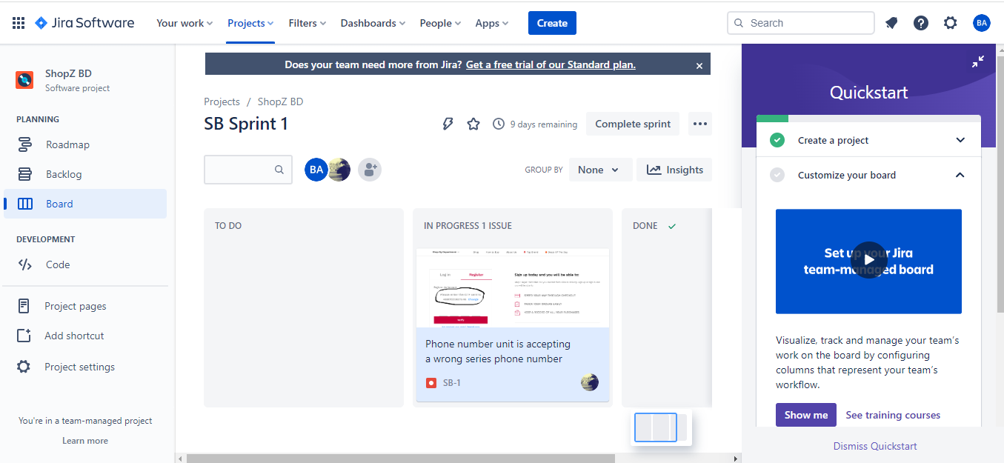

# Developer solve this issue and the issue is now in the “Done” phase.

